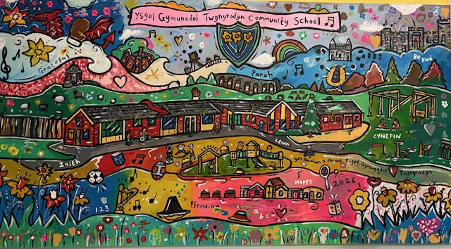

Dear Parents/ Carers

We look forward to welcoming you all into Nursery in September.

Giving our pupils the best possible start in life

The Nursery Team
Twynyrodyn Community School

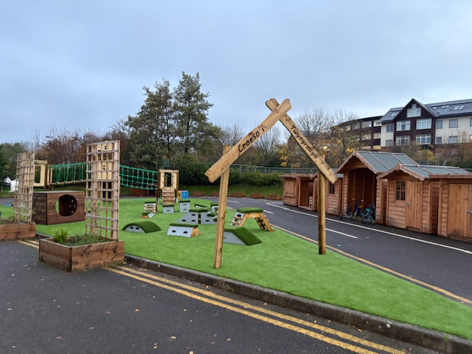

Dear Families,
Starting Nursery is a wonderful milestone, filled with exciting new experiences, friendships, and opportunities to learn and grow. We hope your child will feel happy, safe, and valued as they begin their journey with us, creating special memories along the way.

We know that starting Nursery is an important step for the whole family. Building strong relationships through open communication is at the heart of everything we do, and we hope this booklet helps you and your child feel informed, reassured, and excited about the months ahead.

We are looking forward to getting to know your child, celebrating their unique personality, and supporting them as they grow in confidence and independence. If you have any questions, please don't hesitate to ask—we are always here to help.

This is the beginning of a very special journey, and we feel privileged to share it with you and your family.

Significant People in our School that you may need to know.

Mrs J. Jones Nursery/Reception Teacher
Mrs D. Wells HLTA Nursery Lead
Miss R. Harris Learning Support Assistant
Miss L. Tyler Learning Support Assistant
Miss K. Watson Head Teacher
Mrs M. Davies Deputy Head Teacher
Mr S. Olden Additional Learning Needs Co-Ordinator
Miss S. Pollard School Clerk

What is the Nursery provision?
Merthyr Tydfil County Borough Council currently offers pupils a minimum of 12.4 funded hours of Nursery Education per week for ALL children (from the term following their 3rd birthday). Currently our Nursery are full time (8.50-2.50am), although our risers are part time. 8.50-11.20am.

ALL children will be subject to an assessment period of observation to ensure needs are met. This can be for a minimum of 3 terms to enable information from all professionals, including parents, to be gathered with regard to what support/adjustments need to be in place to provide appropriate educational experiences and access. The reason for this is that pupil’s wellbeing is central to effective learning

What will my child need?
- Appropriate clothing for the weather
- A labelled drink bottle
- A piece of fruit in a small container or plastic bag
- A small lunch bag clearly labelled (school dinner children not applicable for our risers)
- Spare clothing for toilet accidents in a carrier bag with your child’s name on
Please ensure all items are clearly labelled with your child’s name.
What should my child wear?
It is the expectation that all pupils will wear school uniform- however these do not need to have the school badge on.
All items should be labelled with your child’s name.

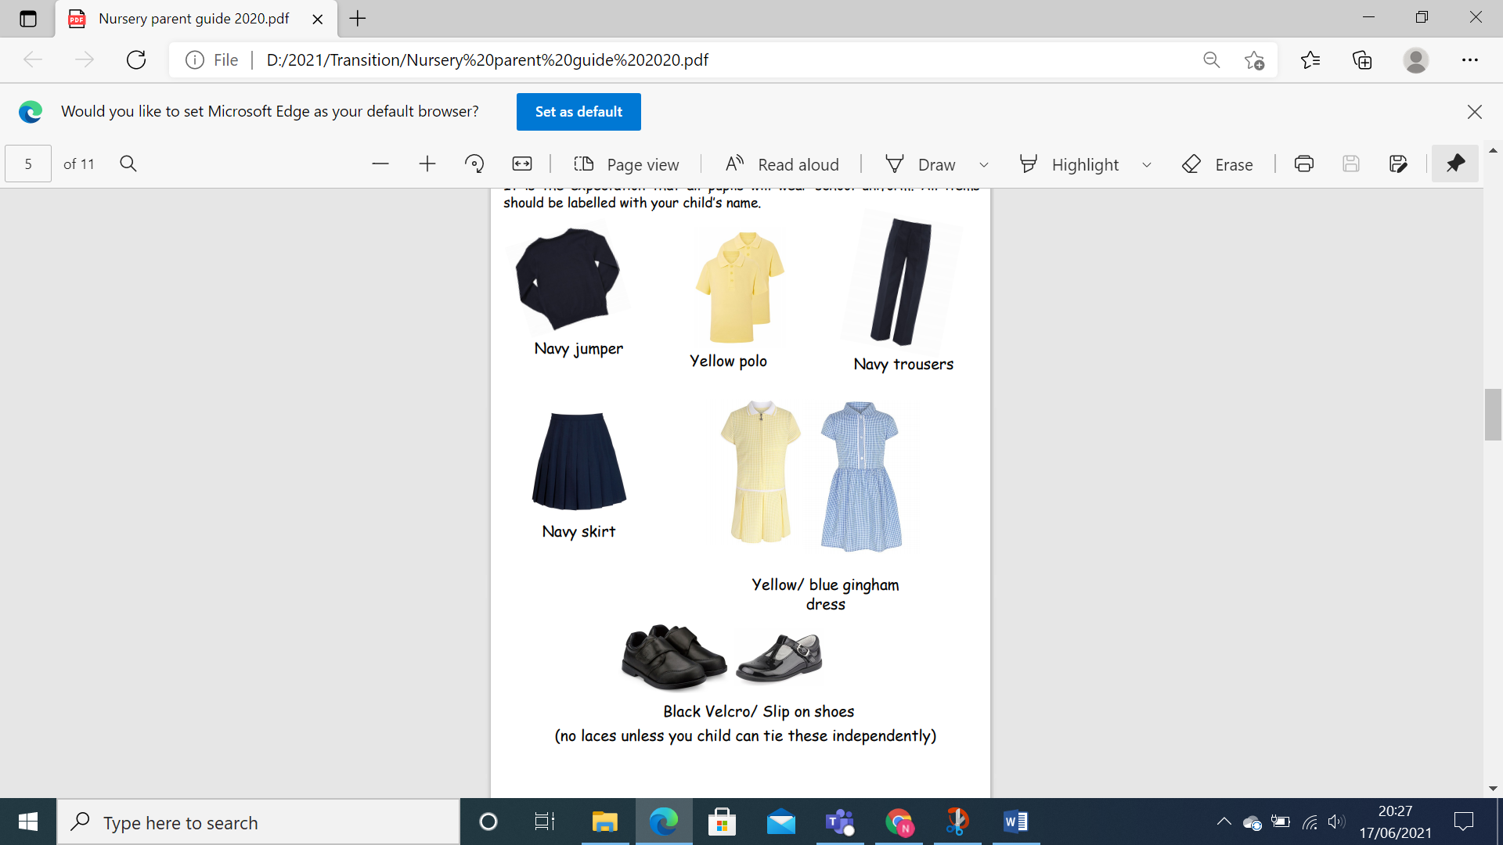

What will happen in the first term?

During the first few weeks, Nursery staff will focus on helping your child settle into their new environment. We will spend time getting to know them, building positive and trusting relationships, and supporting them as they begin to form friendships with other children.

Once your child has settled, we will introduce a range of activities to help us find out what they already know, what they can do, and how they learn best. This information will help us plan meaningful next steps to support their development and progress.

Starting full-time Nursery in a new setting is a big step, and we understand that every child is different. Some children may settle quickly, while others may need a little more time and reassurance. We treat each child as an individual and will provide the care, encouragement and support they need to feel safe, happy and confident in school.

If you have any worries or questions, no matter how big or small, please speak to a member of the Nursery team. We are always happy to help and will do everything we can to reassure you and support your child.

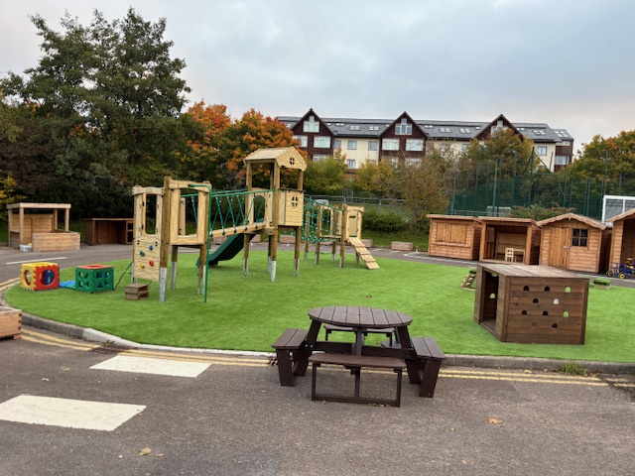

Key Information

During the first few weeks, Nursery staff will focus on helping your child settle into their new environment. We will spend time getting to know them, building positive and trusting relationships, and supporting them as they begin to form friendships with other children.

Starting Nursery is a big step, and regular attendance helps children settle more quickly, build confidence, and develop positive routines. Attending school every day supports your child’s learning, friendships and sense of belonging. Absence can have a negative impact on children’s education and may make it harder for them to feel secure in their daily routines.

Once your child has settled, we will introduce a range of activities to help us find out what they already know, what they can do, and how they learn best. This information will help us plan meaningful next steps to support their development and progress.
Starting full-time Nursery in a new setting is a big step, and we understand that every child is different. Some children may settle quickly, while others may need a little more time and reassurance. We treat each child as an individual and will provide the care, encouragement and support they need to feel safe, happy and confident in school.

Please ensure that you collect your child on time at the end of the school day. It can be very distressing for young children when they see others being collected and they are left waiting. Being punctual also helps children feel safe and secure in their school routine.

If anyone other than a named contact is collecting your child, you must contact the school office in advance to let us know. For safeguarding reasons, staff will not send your child home with someone they do not know unless we have been informed of the change beforehand. Anyone collecting your child must be aged 16 or over.

Children’s safety and wellbeing are always our priority. If you have any worries or questions, no matter how big or small, please speak to a member of the Nursery team. We are always happy to help and will do everything we can to reassure you and support your child.

What should I do if my child is ill or absent from school?

If your child is absent from school, please telephone the school office to let us know the reason for their absence. This helps us keep our registers accurate and ensures we know that all children are safe.
When you call the school, there is an option to leave a message about your child’s absence. The school number is 01685 351804
If your child has sickness or diarrhoea, they must remain at home for 48 hours after their last episode before returning to school. This helps us reduce the spread of illness and keep everyone well.
Head lice are common in all schools, so please check your child’s hair regularly and treat it if needed.
If your child has asthma and needs an inhaler in school, staff can support with this. However, we must have written parental consent before any inhaler can be administered.
Learning in the Nursery

In Twynyrodyn Nursery, we work hard to create a calm, happy and nurturing classroom environment where children feel safe, valued and ready to learn. Our daily routines help children settle, build confidence and enjoy learning and playing alongside others.

During the first few weeks, we focus on helping children to be kind, caring and respectful towards one another and their classroom environment. We encourage the children to value our resources, understand that everything has a place, and develop independence by choosing, using and tidying away activities at the end of each session.

Learning in Nursery is rooted in play, curiosity and exploration. Children are encouraged to follow their own interests, ask questions, investigate and make discoveries through child-led learning experiences. Adults carefully observe, support and extend children’s thinking, helping them to develop skills across the curriculum in a meaningful and enjoyable way.

During Focus Tasks, children work in small groups with an adult who supports and enables their learning. These activities help us introduce and develop important skills while still allowing children to learn in practical, engaging and age-appropriate ways.
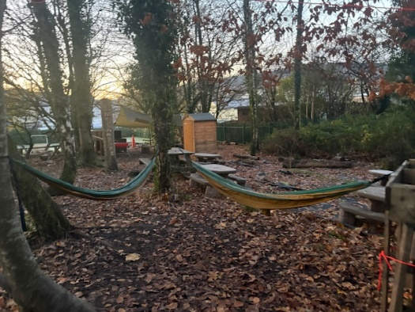
Our indoor and outdoor learning environments are equally important. Children have regular opportunities to learn through free-flow play, both inside and outside, where they can explore, create, problem-solve and develop confidence. We place a strong emphasis on outdoor learning, as it supports children’s wellbeing, physical development, imagination and curiosity about the world around them.
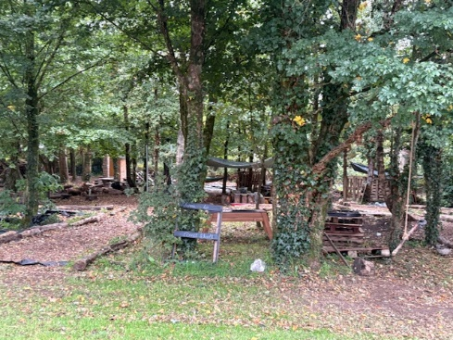
Forest School is also an important part of our Nursery experience. Through Forest School sessions, children are encouraged to explore the natural environment, take safe risks, work together and develop resilience, independence and a love of nature.

Throughout the day, children are supported to become more independent by learning to access their snacks, coats, bags and belongings. These everyday routines help children understand that there is a place for everything and encourage them to take responsibility for themselves and their environment.
You will be able to follow your child’s learning journey on Seesaw, where we will share regular updates and examples of the wonderful learning taking place in Nursery.
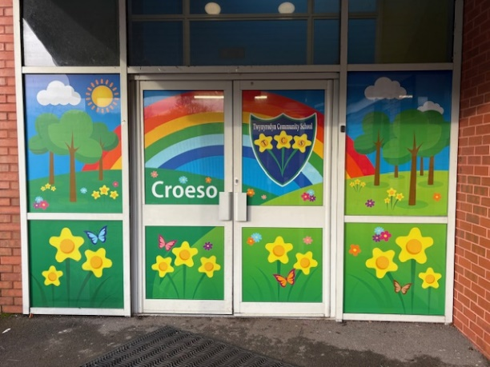

We look forward to meeting you properly and getting to know your child better.
Team Twyn

How can I help my child?
As a school we pride ourselves on our positive relationships with our parents and families. Whilst your child attends Twynyrodyn Community School there will be plenty of opportunities for you to be actively involved in your child’s learning in a number of ways, including.

- Reading with and to your child
- Communication via Seesaw
- Attendance at parents’ evenings
- Information meetings
- Celebration Assemblies/Concerts

Medication - If your child is prescribed medication by your GP, we are willing to administer this throughout the school day. Please bring it to the office and complete a medical form for us to be able to do this.

Communication

Email :- office@twynyrodyn.merthyr.sch.uk

Telephone:- 01685 351804

Website:- https://www.twynyrodyn.merthyr.sch.uk/home

Teachers2parents- You will automatically signed into this texting service when your child is added to our registers. This is due to change soon to an upgraded email service.

Parentpay - When your child is added to our system, you will be sent home details of how to set up to Parentpay. On this platform you will need to book your child a dinner by 7:45a.m. each day. Dinners will be free, but you still need to book. However, you are able to prebook dinners up to 2 months in advance. This platform is also used to pay any monies to school e.g. school trips, consents etc.

See-saw- A QR code will be given to you when your child starts. When you click on the code, you will be able to see what your child has been doing in school.

Newsletters- These will be sent out on a regular basis to keep you up to date with news, events and activities.

