Dear Twyn Community,
Thank you for all the support, as we near the end of our half term. It has certainly been busy! Thank you also to all of the parents who have been to chat with me on the gate, or joined me for the coffee and a chat. You have certainly made myself, and the new members of staff, feel very welcome.
General Reminders
Car Parking and update – The Local Authority are busy working towards improving the safety of our car park. The permanent safety bollards have been installed on the pavements, and we are now awaiting marking up of the bus stop and drop-off zones, as well as pavement buddies. The timing of the lights have also been adjusted to allow for a smoother exit. The aim is to eventually reopen the car park when the works have been fully actioned – although this will need to be monitored to ensure safety. We will let you know when that is. In the meantime, may we kindly ask that only those families with blue badges or mobility difficulties use our car park between 8.45-9am and 2.45-3.10pm. The car park still remains open for Breakfast Club drop-offs, collection during the school day and after school clubs - just please use the bays allocated. Thank you.
Jewellery - Due to health and safety, our guidelines for jewellery allow our children to wear one pair of stud earrings and a watch. Both of which need to be removed for our PE sessions. If your child can not remove them for PE, then please aid your child by taking earrings out in the morning for PE days. Children will be asked to remove extra items and store them in their bags. There has been no change in the school policy and thank you to the parents for working with us to ensure the children’s safety.
Make up - Children are welcome to wear nail varnish, but not false nails or press on nails, due to health and safety. No make-up is permitted at all in school.
Snack - Please encourage your child to bring a healthy snack in for break time. Our pupil Health and Wellbeing ambassadors are working with the school on making healthy choices every day.
PTFA - Our PTFA volunteers are hard at work behind the scenes, although they would always appreciate an extra pair of hands. If you have great ideas, or an hour or two to spare, or just available on the day for events - then please get involved! You can email them directly at ptfa@twynyrodyn.merthyr.sch.uk

Visits and Visitors
The children thoroughly enjoyed the history workshops with Mel from Gweithdy Rhyfel Byd Cymru, learning about life in Wales during the times of WW2, the Victorians and the Romans. They dressed up, handled artefacts and were able to ask a multitude of questions.
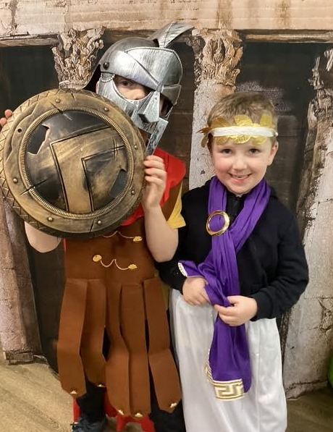 | 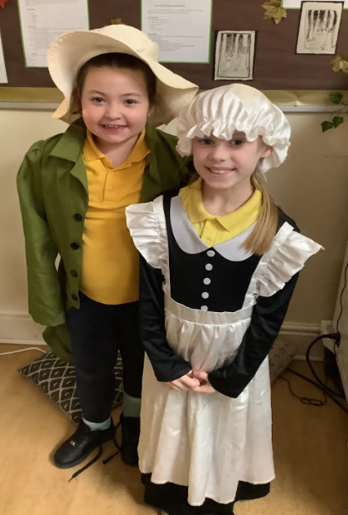 | 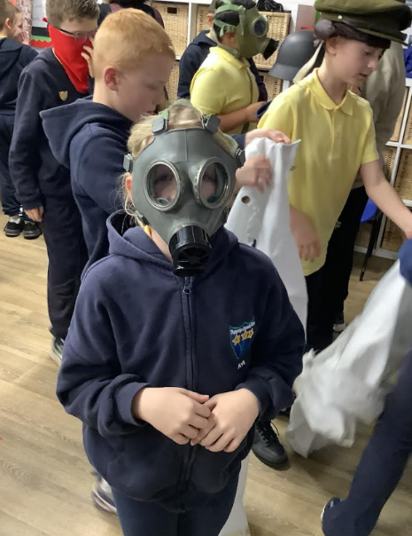

Rob Palser, our chess guru, is still working with the Year 5 and 6 pupils on developing their chess skills this term. Rob also runs a Chess Club in Dowlais Community Centre for budding chess players – it is every Thursday 3.30-5pm, you can book by contacting 01685 377688.
Year 6 enjoyed their transition day in Cyfartha High, and have a cluster disco this Thursday if they wish to attend.
Rhiannon Roberts, a Welsh artist, has worked with our Year 3 and 4 children to create this amazing mural of our school, and has incorporated key landmarks of Merthyr. This is now up in our entrance way and is a perfect welcome to our school.
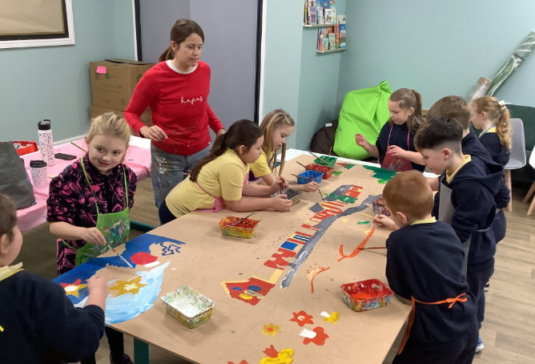 | 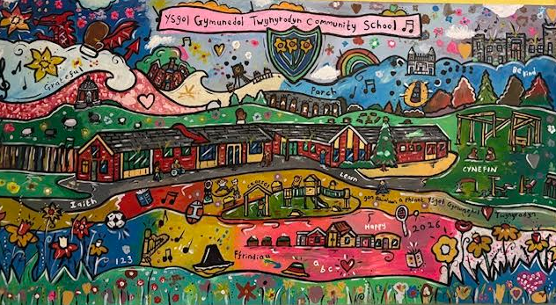

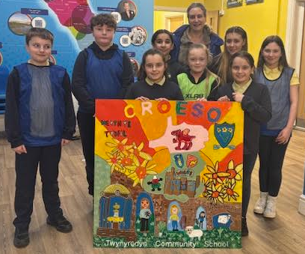
Before Christmas our Year 6 produced art work with the local artist Justine Stroud. This was delivered back to us last week, and now welcomes all our community as you come on to site. Fantastic work Year 6!

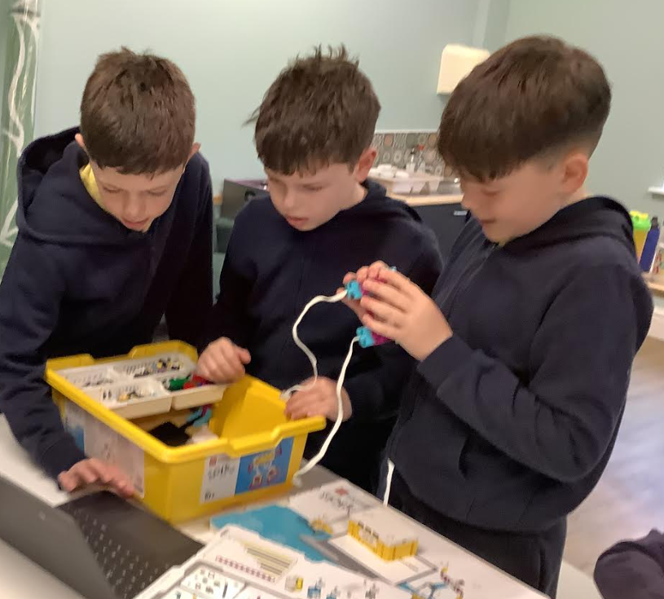
Year 6 have also participated in a Lego Challenge coding workshop, where the pupils have built and created moving robots and learnt to code their creations. This STEM project was funded through the authority and Tilbury Douglas. Mrs Williams’ Year 6 class have had great fun! Mr Jones’ Year 6 are booked in for the 23rd February.
This term the school nurse will be visiting Year 6 to discuss changes to their bodies as part of the puberty talk. The nurse, and ambassadors of the period dignity charity, will also talk to the Y5 & 6 girls about periods too, during their visit.
Year 5 & 6 are visiting Cardiff Castle on 11th February as part of their topic.
Years 1 & 2 are visiting Caerleon on 9th March as part of their topic.
Volunteers from EE have visited the school this half term, and have painted the new Community room, which is getting ready to be repurposed. They also tidied up our Forest School site after the winter. A huge thank you for their ongoing support in improving our school grounds. A small donation from the Community Focused Schools’ team has also supported the purchasing of the furniture for the community room too – it is all coming together. Thank you!
Our school Criw Cymraeg visited Ysgol Santes Tudful last week to meet their Criw Cymraeg and to plan how together they can improve Welsh in our school – they have lots of plans! Watch this space!
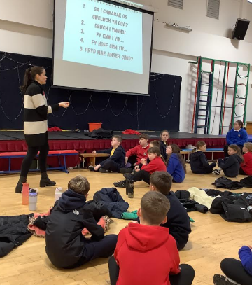

Pupil Voice Section
Our Eco Warriors – Thank you to those children who are walking to school, or doing ‘Walk and Stride’. The children are logging their journeys daily, thank you for the support. The Eco committee will be giving out the badges in assembly.
School Council – We are currently thinking of different names for our phases rather than using Foundation Phase or KS2 as these don’t link to our Curriculum for Wales. The School Council want inspiring names for N-Y2, and Y3-Y6 and have set a competition to name these pathways.
They are also looking at themes to use to name our actual classes also – we have 11 classes in total, and would love them to have names that reflect our community or our school. All ideas gratefully received – the electronic form will be shared by Mrs Jones and the School Council soon, so that families can share their ideas too.
Health and Wellbeing – The committee are currently looking at healthy snacks and improving opportunities for healthy living. We now have a fruit bowl in reception and have Cardiff Rugby booked in for taster sessions after the half term for Years 3-5. Year 6 will be participating in a health and wellbeing course with Cardiff Rugby over 6 weeks.
Digital Champions – The champions have been looking at how to keep passwords safe within the class and how to stay safe online.
Criw Cymraeg – This is a message directly from the Criw…
We are the Criw Cymraeg for Twynyrodyn. We want to encourage people to speak more Welsh in school and at home. We visited Ysgol Santus Tydfil last week to meet with their Criw. This helped us understand Welsh more and we looked at ways we can make Welsh more exciting in our school. We are introducing a Welsh phrase for the fortnight for the children to practise in school and at home. Our phrase is 'Sut wyt ti'n teimlo?' which means ‘How are you feeling?’ and ‘Beth sy'n bod?’ which means ‘What's the matter’? Please practise using these at home. Your child will also receive a letter on Thursday which will be put onto Seesaw. This will tell you about the School's Eisteddfod Creative competitions which they can complete over half term. The entries will need to be brought back to school on Monday 23rd February.
Diolch yn fawr Criw Cymraeg
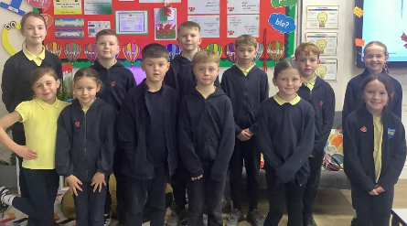

Dates for the Diary
11/02/2026 PTFA Valentines Disco (R-Y2 3pm-4pm, Y3-Y6 4.15pm-5.15pm) The closing date for tickets has unfortunately gone. Nursery pupils will have their own disco in class that day, so they can join in the fun too! N-Y2 can wear their disco clothes to school so that they are party ready!
12/02/2026 Y6 Cyfartha High School Cluster Disco.
13/02/2026 Dydd Miwsig Cymru – Celebration of Welsh music of all different genres!
23 + 24/02/2026 Cardiff Rugby Taster Sessions for Y3-Y5. Start of Y6 Health and wellbeing sessions.
23/02/2026 Mr Jones’ Y6 Lego STEM workshop.
26/02/2026 Cluster Eisteddfod - our school winners will be representing our school in
the cluster (Good Luck!)
27/02/2026 ‘A Taste of Wales Day’ - a carousel of fun activities connected with our
Welsh culture. Children will enjoy and celebrate the diversity of Welsh
culture in a fun and engaging day.
02/03/2026 Dydd Gŵyl Dewi - Our school St David’s Day celebrations and Eisteddfod.
Please wear your Welsh costumes with pride.
02+03/03/2026 Family Progress Meetings – Booking link to be sent nearer the time.
05/03/2026 World Book Day - Let’s dress up and celebrate our favourite characters!
20/03/2026 Into Film – Trip for Y3-Y6 to watch Bad Guys 2 at the Vue.
26/03/2026 Our friendly PTFA Easter bunny will be visiting.
27/03/2026 Last day of term for Easter. Back to school on 13/04/2026
01/05/2026 Advance notice of INSET Day, school closed for children.
07/05/2026 Advance notice of INSET Day, school closed for children.
02/07/2026 Early notice for Twyn Fest 2026!
Warmest wishes,
Katy Watson and Team Twyn

