Twynyrodyn Community School Pupil Development Grant School Statement
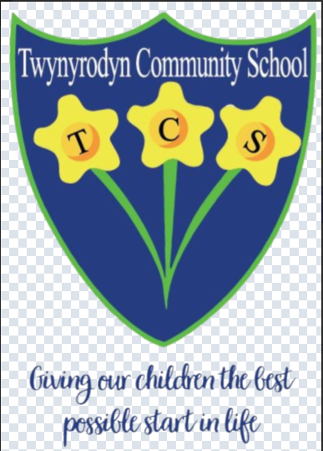
This statement details our school’s use of the PDG for the 2025 to 2026 academic year.
It outlines our strategy, how we intend to spend the funding in this academic year and the effect that last year’s spending had within our school.
School Overview
Detail | Data
School name | Twynyrodyn  Community School
Number of learners in school | 269
Proportion (%) of PDG eligible learners | 15.99%
Date this statement was published | October 2025
Date on which it will be reviewed | October 2025
Statement authorised by | Judith Edward
PDG Lead  Governor Lead | Judith Edwards  Kim Smart

Funding Overview
Detail | Amount
Schools Equity Funding | £70,150

Part A: Strategy Plan
Statement of intent
● The intent of this plan is to use available funding to reinforce our school vision of ‘giving our children the best possible start in life’ through providing targeted support to those who are eligible to allow them to access our curriculum fully and make the best progress possible.

Intended outcomes
This explains the outcomes we are aiming for by the end of our current strategy plan, and how we will measure whether they have been achieved.
Intended outcome | Success criteria
Support the well-being of our most vulnerable learners. | Trends tracked on Motional show a positive impact of the programme on the majority of the targeted children.
Develop the speech and language skills of those entering nursery with a marked deficit. | Termly assessments show progress for all verbal children with English as a first language.
Support targeted pupils academically to develop key literacy and numeracy skills. | Progress evident in phonics screens, spelling tests and numeracy diagnostic assessments.

Develop strong links with new starters to the school.
Activity in this academic year
Pupils, parents and staff establish positive early relationships with families that demonstrate our culture and make transition into school a positive process.
This details how we intend to spend our PDG this academic year to address the challenges listed above.

Learning and teaching
Budgeted cost: £ 65,709.28
Activity | Evidence that supports this approach
One LSA one day a week to run | Our use of Motional has clearly demonstrated the impact of traumatic events on the ability of our children to effectively access daily school life. The Motional sessions
well-being  interventions.  One LSA three days a week to run  well-being  interventions. | with Trauma Informed Schools trained staff provide them with experiences and strategies to address their barriers to learning to allow them to better access school life.
One LSA five days a week to run  Well-Comm  interventions. | There is a speech and language deficit amongst some of the pupils entering our nursery, with some children facing significant speech and language difficulties. Dedicated Well-Comm interventions will follow a programme to develop this whilst also providing the tools for regular assessment to support on-going interventions. These will be delivered in class.
One LSA five days a week running  academic  interventions for  targeted children. | Pupils will be targeted on assessment data. Interventions will be required for Sounds Write for this not attaining the pass mark in Year 1 or 2. These will be extended for KS2 pupils who made limited progress in National Tests and  spelling assessments. In class and withdrawal interventions provided for numeracy for those identified via National Tests.

Community Focused Schools (to include: (i) building strong partnerships with families; (ii) responding to the needs of the community; (iii) collaborating with other services)
Budgeted cost: £ 5,000
Activity | Evidence that supports this approach
Nursery teacher and LSA to visit all risers and new pupils at  home or in a  childcare setting  (supply costs).  Visits will happen in the Autumn term for Spring risers, Spring for Summer risers | Early relationship building is essential and makes transition into school better for all stakeholders. Parents have opportunities to ask questions and get to know key staff. Pupils get to meet the adults they will be working with prior to a visit and start date. Staff are able to learn about the pupils and start collecting information to allow for a smooth start to school for our youngest children.
and Summer for
September intake.

Total budgeted cost: £ 70,709.28
Part B: Review of outcomes in the previous academic year
PDG outcomes
This details the impact that our PDG activity had on pupils in the 2024 to 2025 academic year.
Activity | Impact
Improve the progress scores of the children receiving numeracy  interventions | 80% of children to improved their National Test progress score by at least 10.
Provide all eligible  children with access to technology to support learning | All Year 2 and over children have their own Chromebook. Younger pupils have an iPad.
To improve knowledge of the phonics code  To improve the  wellbeing of targeted children | All pupils receiving interventions progressed at least three units through the code, demonstrating a mastery of their knowledge.  Motional tracking charts show positive trends for at least 80% of targeted pupils. Some targeted pupils didn’t make the progress hoped, but this could be attributed to external factors.

Externally provided programmes
Please include the names of any programmes that you purchased in the previous academic year. This will help us identify which ones are popular in Wales.
4
Programme | Provider
Motional | Motional

